EASTERN INTERNATIONAL UNIVERSITY Practice Assignment – Quarter …, 20…-20…
SCHOOL OF COMPUTING Course Name: Special Topic 1
AND INFORMATION TECHNOLOGY Course Code: CSE 484
Student’s Full Name: Hà Quang Minh
Student ID: 1931220012
Lab 3

Background
This lab guides you through low-level to inventory-driven network automation with Pexpect → Paramiko → Netmiko → Nornir. You will verify SSH connectivity, run show commands, push small config changes, and capture evidence for your report. (Virtual environments and Pexpect/Paramiko overviews referenced.)
Clone the DEVASC vm to create a network with at least two routers.

Required Resources:
• 1 PC with operating system of your choice
• VSCode installed with appropriate Python interpreter
• CSR1000V (or equivalent device) can ping your host computer
• Python 3.9+; recommended: use a virtual environment and activate it before coding
• Internet access to install packages: pexpect, paramiko, netmiko, nornir, nornir_utils, nornir_netmiko
Questions:

Part 1: Connectivity & SSH prerequisites

Basic reachability check
Using your favorite command line program, pings each target device (ICMP). Capture the result to your report.
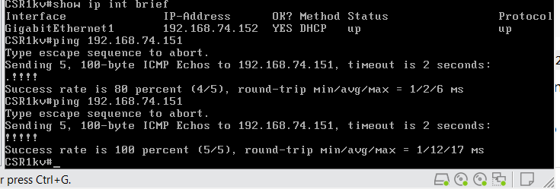
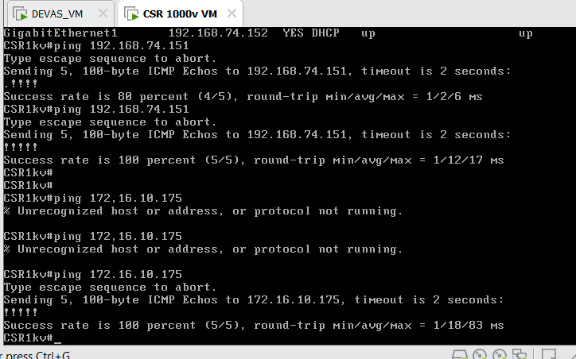

Verify SSH connectivity
From your PC, confirm you can SSH to the CSR1000V with your credentials (or keys).
Capture a screenshot of a successful SSH login (or error if any) in your report.
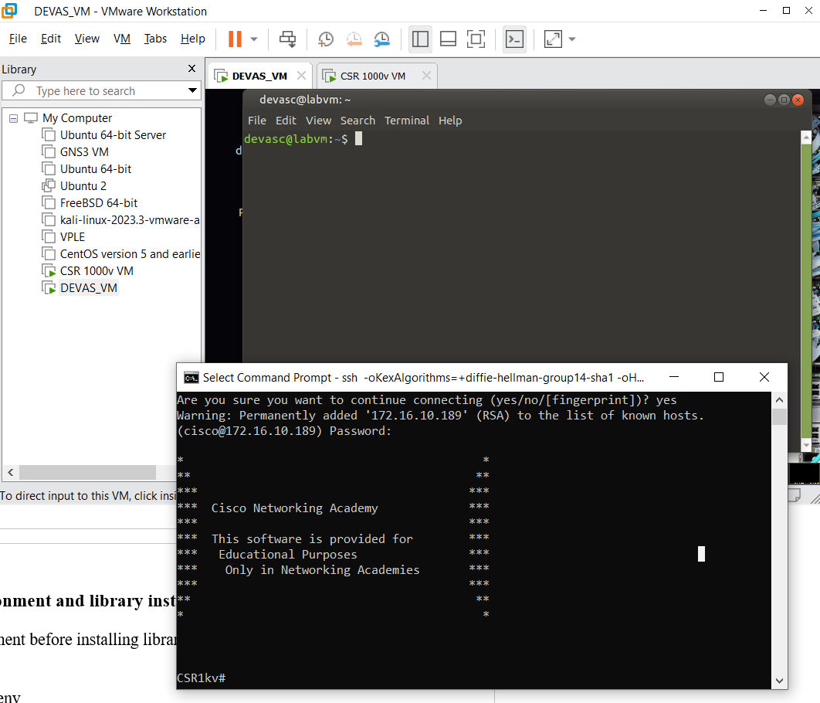

Virtual environment and library install:
- Create/activate a virtual environment before installing libraries.
- Linux example:
  - python3 -m venv venv
  - source venv/bin/activate (always activate before working).
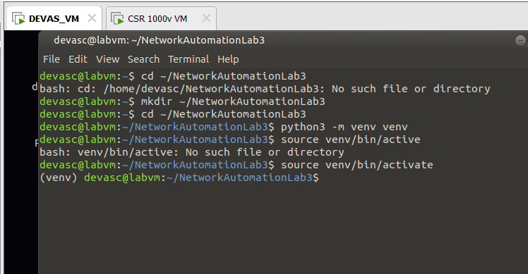
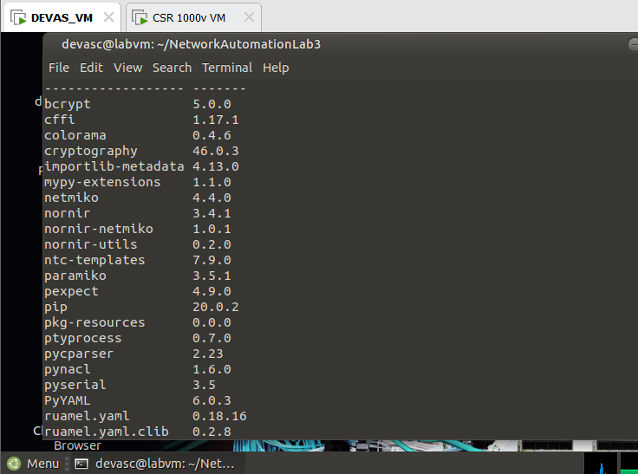

Part 2: Pexpect (interactive automation over SSH)
Theoretical overview (read): Pexpect spawns a child process (like an SSH session) and matches expected prompts/strings. It’s useful to automate interactive CLIs. Install with pip install pexpect.
Tasks:
- Create pexpect_show.py that:
  - Logs in to a router over SSH (disable strict host key checking for the lab).
  - Sends terminal length 0 and show ip interface brief.
  - Prints the full output (no --More--).
Capture the result to your report.
- Extend the script to:
  - Handle slow devices by adjusting timeout and/or using flexible expect patterns (e.g., [Uu]sername).
  - Save command output to a file per device.
Explain how your expect patterns avoid getting “stuck.”
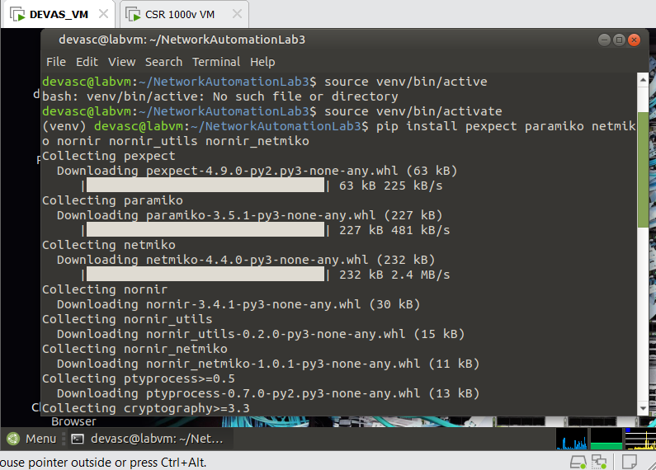

  - 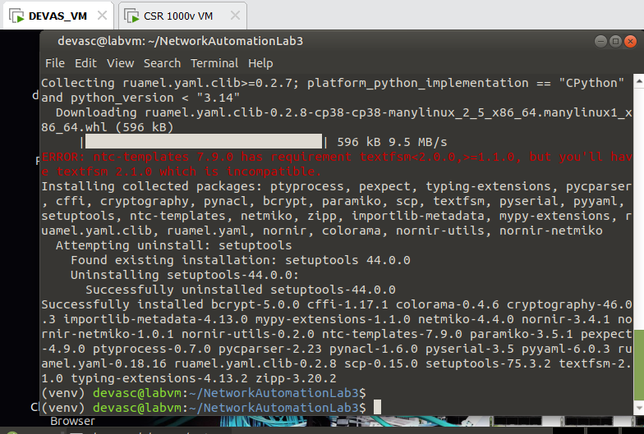
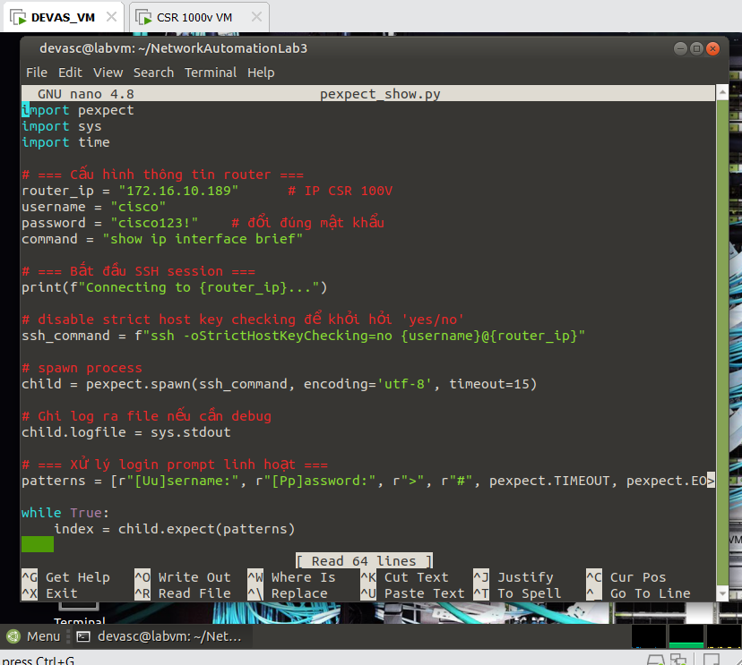
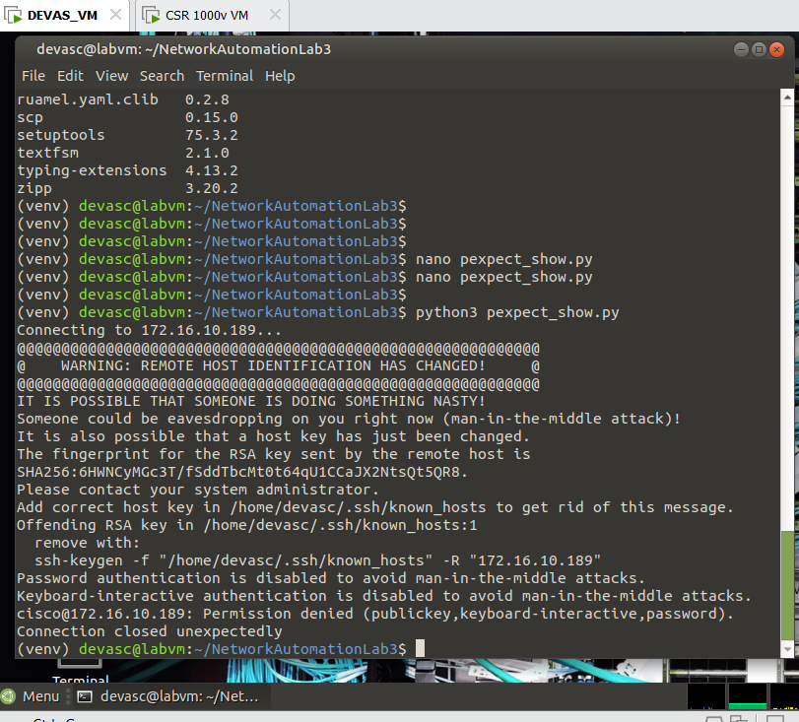
TimeOut | Expect Patterns
Expect() waits for one of the strings in the list ( “Username” , “Password”, “#”  If the router is shlow set timeout=30 to avoid timeout | Pattern [Uu]sername : allows to reveive both “Username:” and “username”  Use child.before to get the output before matching prompt (#) avoid sticking the prompt to the data  If there is no terminal length 0, the output wll be interrupted by –More—so I turn it off first

Part 3: Paramiko (programmatic SSH client & SFTP)
Read/Install: Paramiko implements SSHv2; install prerequisites (cryptography) and Paramiko, then verify import.
Tasks:
- Create paramiko_show.py that:
  - Connects with username/password (no agent/keys for the lab).
  - Runs show version (or uname -a on a Linux target) and prints output.
Capture the result to your report.
- (Optional) Create paramiko_sftp.py to download a small text file from the device/server using SFTP.
Note: For multiple commands in one SSH session on Cisco IOS, use an interactive shell instead of exec_command() which is limited; explain in 2–3 sentences.
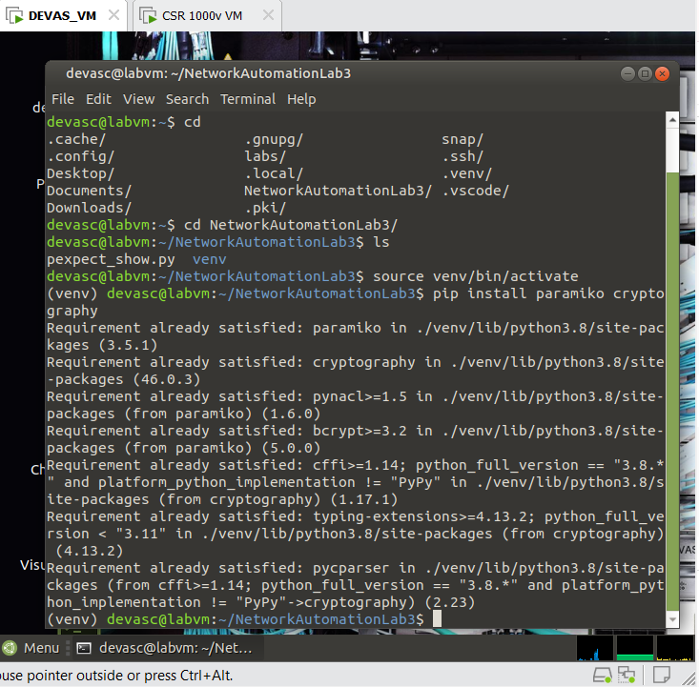

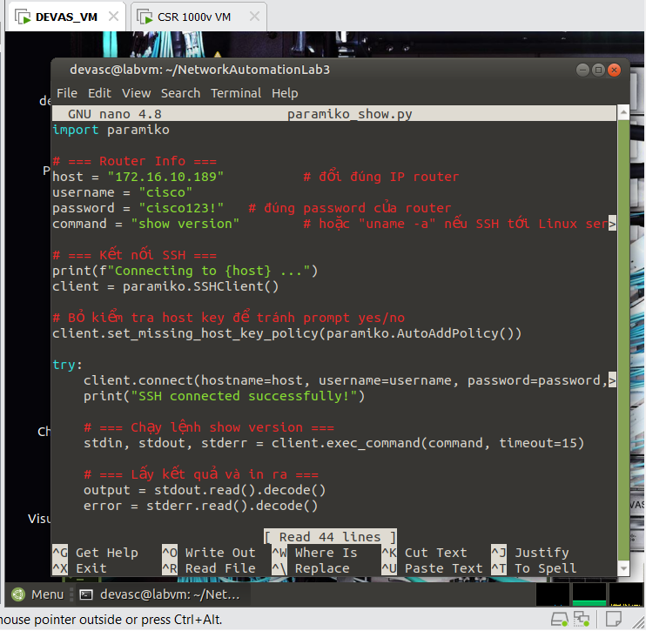
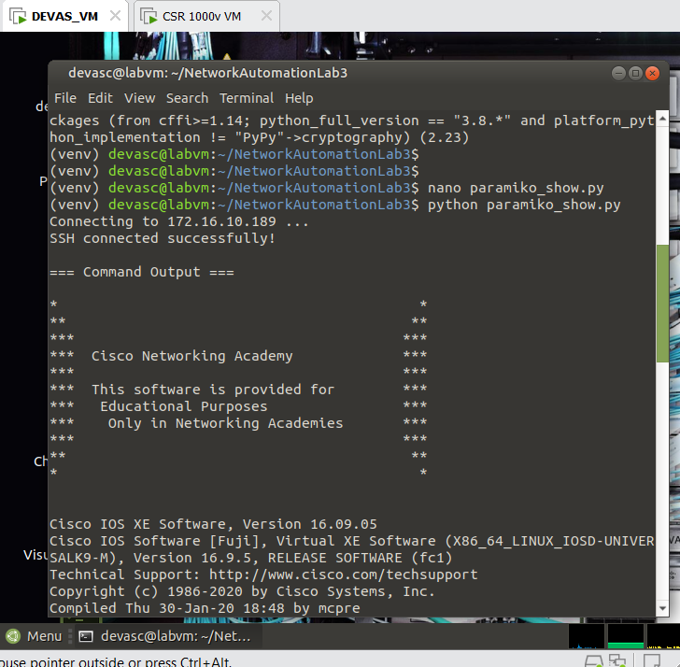

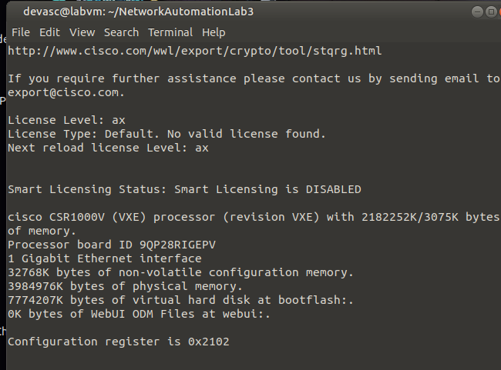
Step 2 : Optional
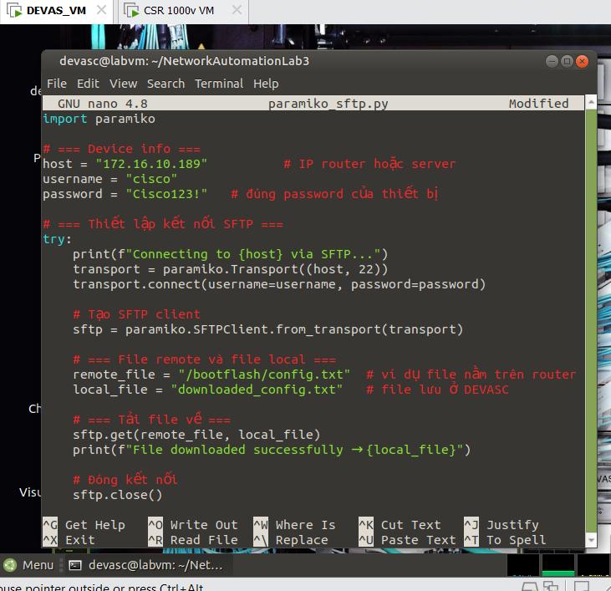

Part 4: Netmiko (CLI automation with prompts/modes handled)
Tasks:
- Install Netmiko and create netmiko_gather_and_cfg.py that:
  - Connects to two devices (192.168.2.51, 192.168.2.52).
  - Runs show ip interface brief.
  - Pushes two config lines:
  - logging buffered 19999
  - no ip http server
  - Prints device responses.
Capture the result to your report.
Add basic error handling (timeout/auth exceptions) and write outputs to logs/<host>_*.txt.
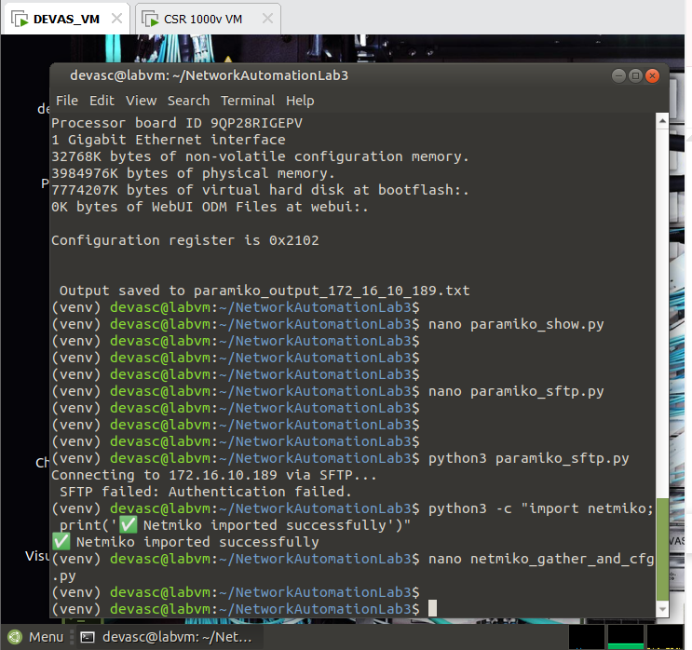

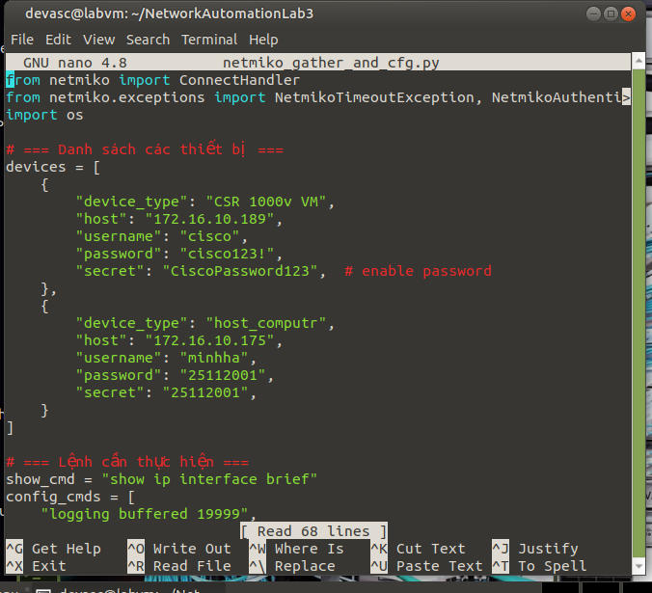
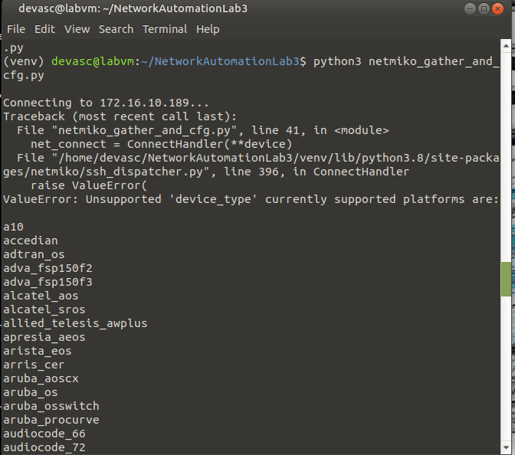

Part 5: Nornir + Netmiko (inventory-driven, one run across many devices)
Theoretical overview (brief): Modern frameworks (e.g., Nornir) abstract much of the line-by-line interaction while still using transports such as Paramiko under the hood.
Tasks:
- Build a SimpleInventory:
config.yaml
inventory:
plugin: SimpleInventory
options:
host_file: inventory/hosts.yaml
defaults_file: inventory/defaults.yaml
inventory/hosts.yaml
r1:
hostname: 192.168.2.51
platform: cisco_ios
r2:
hostname: 192.168.2.52
platform: cisco_ios
inventory/defaults.yaml
username: cisco
password: cisco
connection_options:
netmiko:
extras:
secret: cisco
- Create nornir_push.py that:
  - Runs netmiko_send_command for show ip interface brief and saves outputs per host.
  - Runs netmiko_send_config with logging buffered 19999.
Prints a uniform summary of results.
Capture the result to your report.
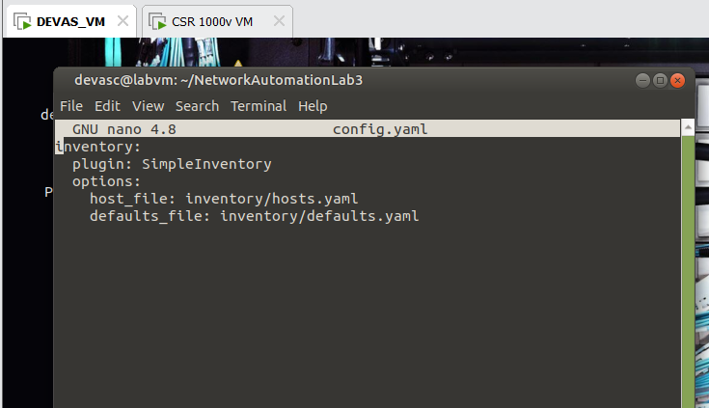

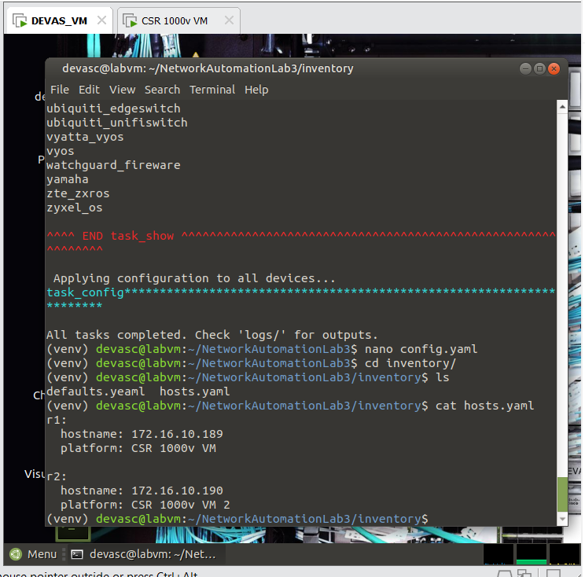

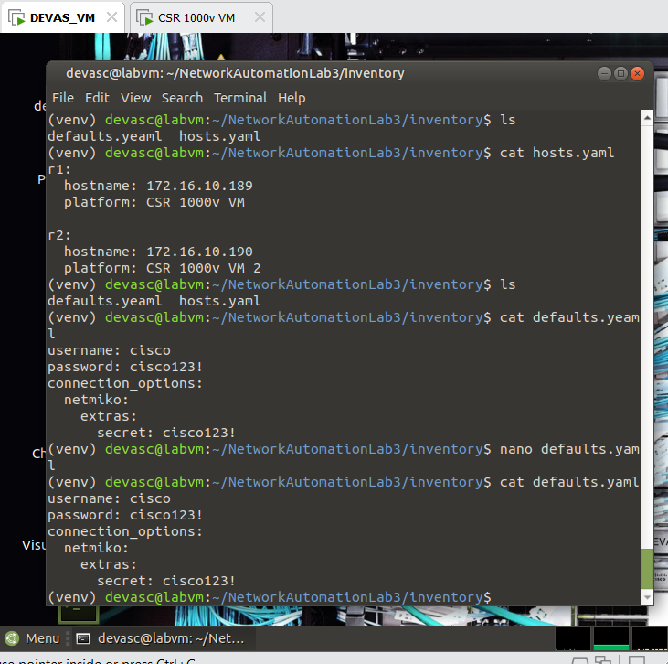
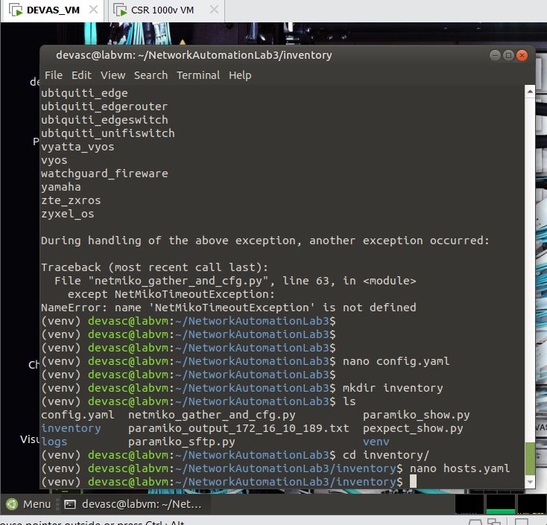
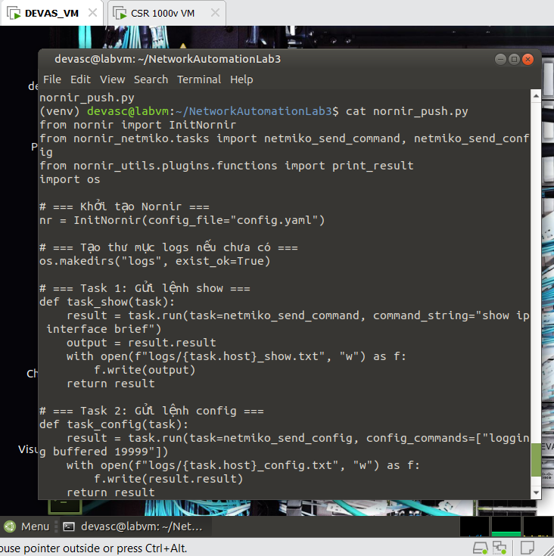

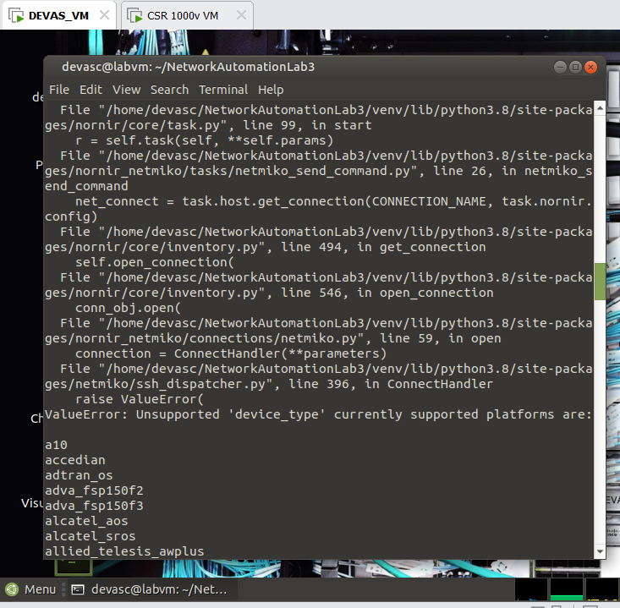

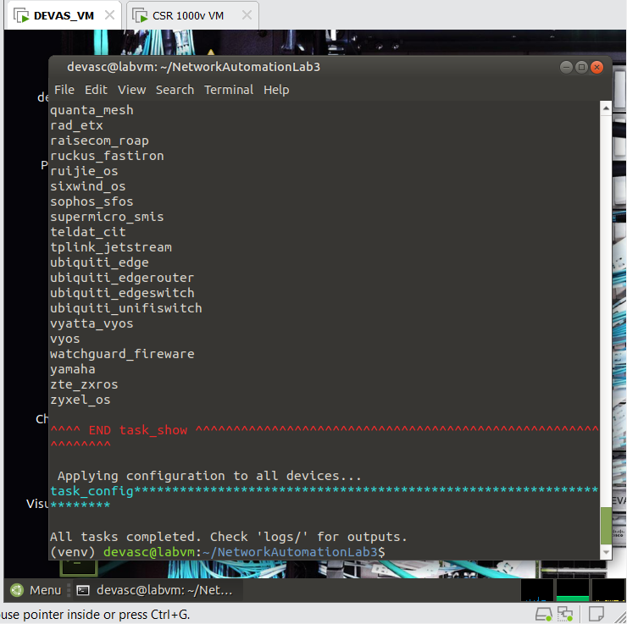
Submission: Must include:
- a pdf report file containing your information (student id, name), and images of the diagrams, codes, answers, evident,…
- and all source code files (if any)
in a zipped (.zip or *.rar) file to Moodle

